# SMART SECURITY SYSTEM FOR HOMES

The project is submitted during the internship Program

In

SMART BRIDGE

By

**PADALA VASUDHA**

Under the esteemed guidance of

**Mr. RACHURI HARISH**

During the period of May(2019)-June(2019)



***Abstract:*** Security is the main concern of the world now days. Sensor based home security system are the high technology and methodical systems which connect wirelessly and ensure real time operation and indication of the threat to the house.

The idea of comfortable living in home has changed since the past decade as digital, vision and wireless technologies are integrated into it. Now-a-days internet plays a major role in every area, so integrating sensors technology with an IOT environment could resolve the security issues of society to a great extent. The various drawbacks of existing technologies are cost and range.

This project concentrates on building a sensor-based security system with an IOT environment, which will resolve security issues such as unauthorized intruder entry, therefore continuous monitoring of the home/apartment is possible. The system is cost effective, reliable and has low power consumption.

Hardware: Raspberry pi 3B board, IR sensor, HC-01(flame senor), Logitech camera with USB Mike.

Software: Python IDE, IBM cloud platform, MIT App Inventor.

***HARDWARE:***

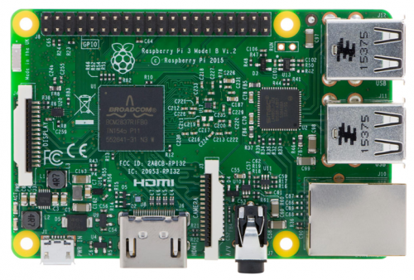**RASPBERRY PI MODEL 3B:** The **Raspberry Pi** is a series of small single-board computers developed in the United Kingdom by the Raspberry Pi Foundation to promote teaching of basic computer science in schools and in developing countries. The original model became far more popular than anticipated, selling outside its target market for uses such as [**robotics**](https://en.wikipedia.org/wiki/Robotics). It does not include peripherals and [**cases**](https://en.wikipedia.org/wiki/Computer_case). However, some accessories have been included in several official and unofficial bundles. The organization behind the Raspberry Pi consists of two arms. The first two models were developed by the RaspberryFoundation. After the Pi Model B was released, the Foundation set up Raspberry Pi Trading, with Eben Upton as CEO, to develop the third model, the B+. Raspberry Pi Trading is responsible for developing the technology while the Foundation is an educational charity to promote the teaching of basic computer science in schools and in developing countries.

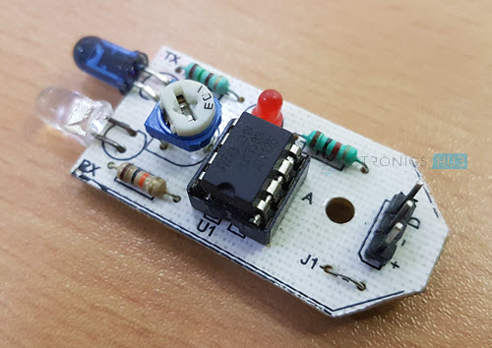**Infrared Sensor**

Infrared Sensors or IR Sensors are one of the frequently used sensor modules by electronics hobbyists and makers. They are often used as Obstacle Detecting Sensors or Proximity Sensors.IR Sensors emit and receive Infrared radiation. They are often used as Proximity Sensors i.e. detect and alarm if an object is close to the sensor.

An IR Sensor Module basically consists of three parts:

* an IR Transmitter,
* an IR Detector,
* a control circuit.

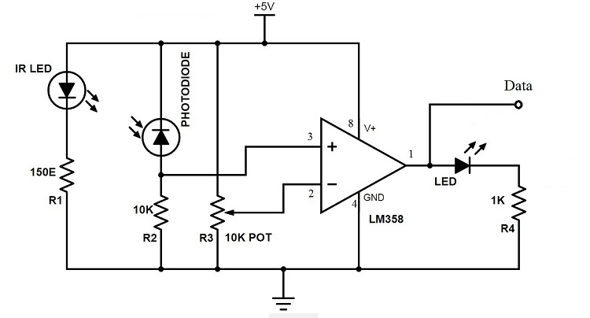Usually, an IR LED is used as an IR Transmitter and a Photo Diode or a Photo Transistor (less often) is used as an IR Detector. The control circuit consists of a Comparator IC with necessary components.

* Photodiode
* 10 KΩ Resistor
* 10 KΩ Potentiometer
* LM358
* LED
* 150Ω Resistor
* 1 KΩ Resistor

**CAMERA:**

* 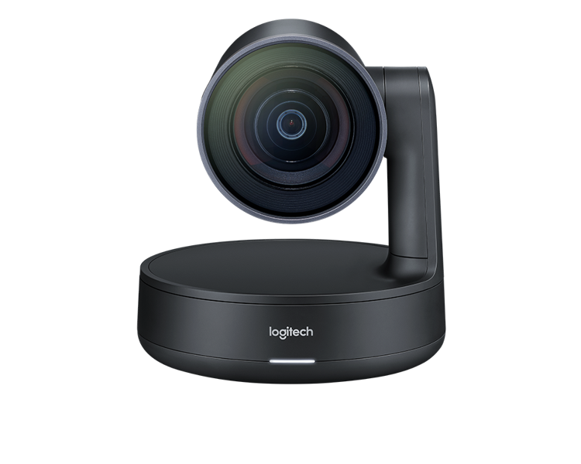Video capture: Up to 1280 x 720 pixels
* Logitech Fluid Crystal Technology, Photos: Up to 3.0 megapixels (software enhanced)
* Built-in mic with noise reduction, Hi-Speed USB 2.0 certified (recommended)
* Universal clip fits laptops, LCD or CRT monitors
* You can be heard loud and clear thanks to a built-in microphone that reduces background noise.

**BUZZER**

* 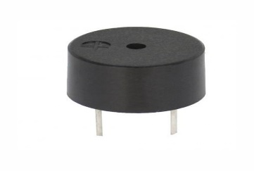A **buzzer** or **beeper** is an audiosignaling device which may be mechanical, electromechanical, or piezoelectric(*piezo*for short). Typical uses of buzzers and beepers include alarm devices, timers, and confirmation of user such as a mouse click or keystroke.

**FLAME SENSOR(HL-01)**

**Usage:** These types of sensors are used for short range fire detection and can be used to monitor projects or as a safety precaution to cut devices off / on.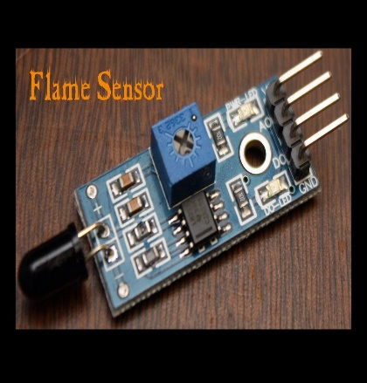

**Range:** I have found this unit is mostly accurate up to about 3 feet.

**How it works:** The flame sensor is very sensitive to IR wavelength at 760 nm ~ 1100 nm light.

Digital output : When the temperature reaches a certain threshold, the output high and low signal threshold adjustable via potentiometer.

**Pins:** VCC-Positive voltage 3.3v for Digital.

Digital pin- BCM 21,GND- Ground

HANDS ON:

CODE:

from gpiozero import LED

from signal import pause

import RPi.GPIO as GPIO

import time

import os

IR_PIN = 15

buzzer = 18

LED_PIN = 27

indicator = LED(LED_PIN)

Flame = 21

GPIO.setmode(GPIO.BCM)

GPIO.setup(IR_PIN,GPIO.IN)

GPIO.setup(buzzer,GPIO.OUT)

GPIO.setup(Flame, GPIO.IN)

GPIO.output(buzzer, False)

print "IR Sensor Ready....."

print " "

count = 0

def callback(channel):

print("Flame detected")

GPIO.output(buzzer, True)

GPIO.add_event_detect(channel, GPIO.BOTH, bouncetime=300) # let us know when the pin goes HIGH or LOW

GPIO.add_event_callback(channel, callback) # assign function to GPIO PIN, Run function on change

try:

while True:

if GPIO.input(IR_PIN):

count += 1

indicator.on()

os.system("sudo service motion restart")

print("Video streaming is live on -- 192.168.132.216")

print("{:>3} Got something".format(count))

GPIO.output(buzzer, True)

print "Object Detected"

while GPIO.input(IR_PIN):

time.sleep(0.2)

else:

indicator.off()

print("{:>3} Nothing detected".format(count))

GPIO.output(buzzer,False)

time.sleep(0.2)

except KeyboardInterrupt:

GPIO.cleanup()



**MIT APP UI:**

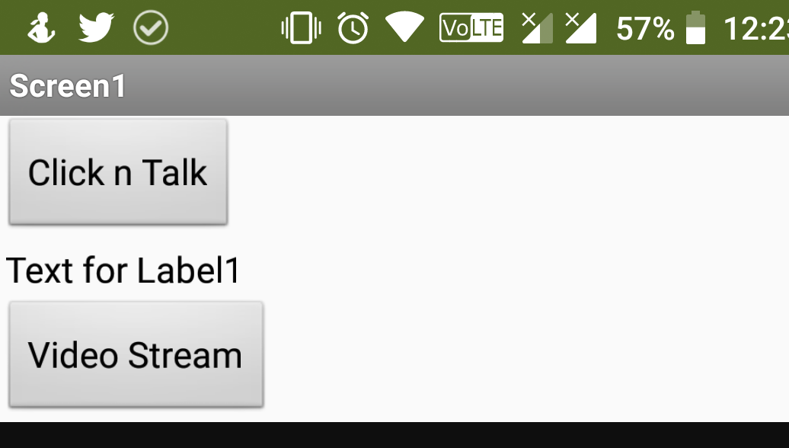

This UI works when the IR sensor detects the object. The detected object can be streamed live by clicking on the “video stream” button. The buzzer also gets triggered when an object is detected. As well the LED will be on when detection takes place.

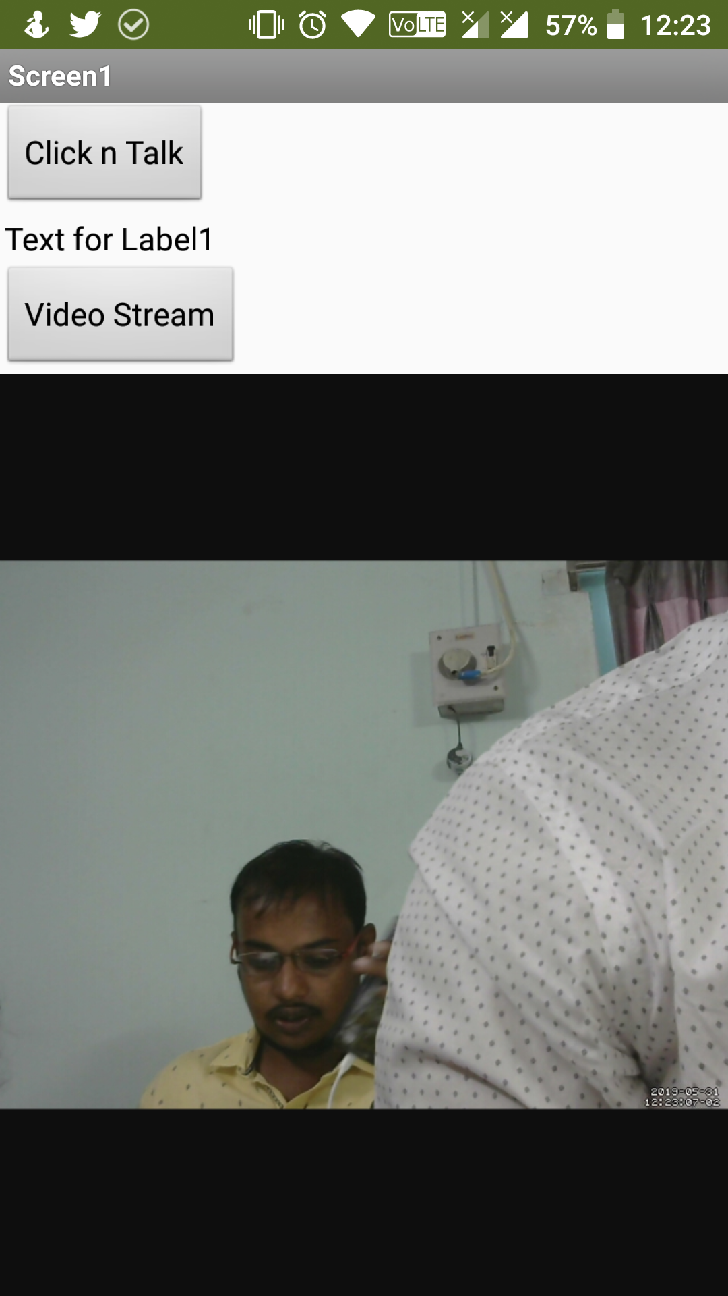

The image shown above is the live video screenshot, this image is detected when the object is detected by the IR sensor.

CONNECTIONS:

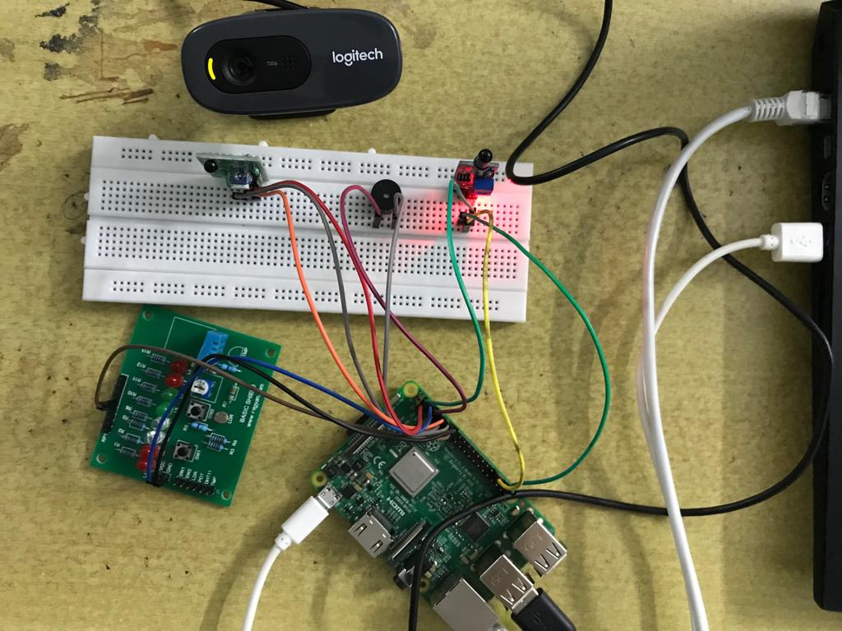

The entire setup is connected to the raspberry pi and is executed using the code in the system.

**TESTING:**

Working of IR sensor:

The testing process starts like this, to test the IR sensor, place a finger or any object on it, if the IR sensor working properly then the LED will glow and Buzzer triggers. To stream the live video MIT App can be used.

Working of Flame sensor(HL -01):

Place the flame near the sensor or a flash light on it, if the buzzer makes a sound then the sensor is working.

**CONCLUSION:**

The project “IOT Based Theft Detection Using Raspberry PI” has demonstrated how to get a fully functional embedded product developed from scratch. This included the cross compilation and deployment of essential libraries. This system is suitable for small personal area surveillance. i.e. personal office cabin, bank locker room, parking entrance. Whenever the motion is detected through. The main Advantage of the project is Easy to implement, Low cost with High quality. Finally,this project can be used for theft detection and fire detection.